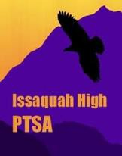GRANT APPLICATION 2018-2019

**IH PTSA MISSION**

To expand educational opportunities and enhance the learning and social

environment at Issaquah High through programs, volunteers, advocacy and financial support.

